Design Review

* Robot at 1st Qualifier

horizontal line **Date:** Sat, Dec 4, 2016

**Location:** Ridgefield Academy, Ridgefield, CT

Ref. Meeting Notes Dec 4 2016 Event- Mountain Matchup Qualifier

|  |  |  |  |
| --- | --- | --- | --- |
| **Major Milestones:** |  | **Completion Goal** | **Completed** |
| Mountain Matchup Qualifier - Ridgefield |  | Dec 4, 2016 | Yes |
| Gator Bowl Qualifier - Greenwich |  | Jan 21, 2017 |  |
| Determined Tigers Qualifier – West Hartford |  | Feb 4, 2017 |  |
| Battle at the Beach – CT State Championship |  | Feb 18, 2017 | Qualified |
| East Super Regional – Scranton, PA |  | Mar 17-19, 2017 |  |
| Worlds Competition |  | Apr 2017 |  |
| Post competition – Hatter’s Scrimmage |  | May 16, 2017 |  |

**Requirements:**

|  |  |  |  |
| --- | --- | --- | --- |
| **Physical Systems –Requirements** | **Required?** | **Status** | **Achieved** |
| Push Beacons | Yes | Some | 4 |
| Side by side beacon pushers | Nice to have | Some | 2 |
| Shoots particles | Yes | None | None |
| Shoots multiple particles (reloads) | Yes | None | None |
| Maneuverable – uses Mecanum Wheels | Nice to have | Good | Good |
| Lifts Cap Ball | Yes | None | None |
| Places Cap Ball on C.Vortex | Nice to Have | Push w bumper | None |

**Agenda:** Review Robot status at 1st Qualifier

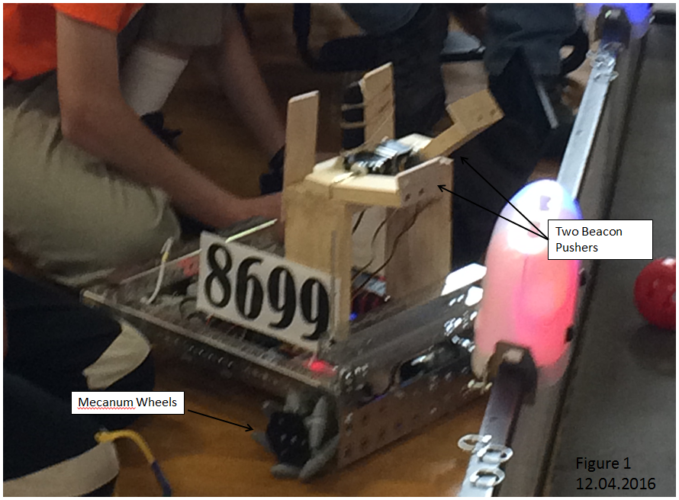

***Observations:***

* Did very well – seeded 8th, qualified for States.
* The wooden beacon pushers – broke at the hinge arrangement.
* To push beacons the robot bashed them and the wall hard.
* The wheels worked well – maneuverable system, but light. Unable to hold ground – a light robot pushed around easily.
* No sensors, no action during autonomous

***Suggested concepts for improvement:***

* Redesign beacon pusher.
* Develop particle shooter
* Develop particle re-loader
* Develop autonomous program

|  |  |  |
| --- | --- | --- |
| **Action Items** | **Assigned** | **Date/Goal** |
| Concepts for beacon pusher redesign | Team | Dec 2016 |
| Concepts for shooter | Team | Dec 2016 |

|  |  |  |  |
| --- | --- | --- | --- |
| **Prepared By:** | Chandler | **Date:** |  |
| **Overview By:** | G. Edward | **Date:** |  |